**Project Report**

**GEOG 689/489**

**Project Members**

**Naga Raghuveer Modala**

**Bradley Thompson**

**Yue Wang**

**Objective:**

The overall objective of this project is to develop an interactive web application (TPCC) to view the bias corrected climate change predictions for Texas PanHandle region. One more objective involves making the web application dynamic and interactive.

**Datasets:**

* Three global climate models - Regional Climate Model Version3–Geophysical Fluid Dynamics Laboratory (RCM3-GFDL), Regional Climate Model Version3–Third Generation Coupled Global Climate Model (RCM3-CGCM3), and Canadian Regional Climate Model-Community Climate System Model (CRCM-CCSM) predicted daily rainfall, maximum temperature and minimum temperature have been downloaded for both historic (1971-2000) and future time periods (2041-2070) from North American Regional Climate Change Assessment Program

Source: https://www.narccap.ucar.edu/

* Counties – 67 counties (Figure 1). Geographic polygon information for each county was obtained from Google Fusion tables.

Source: <https://www.google.com/fusiontables/DataSource?docid=1-phYOKtTOvDnbf7twm0L_Tj1pMBDUFVnEZcq6g#rows:id=1>

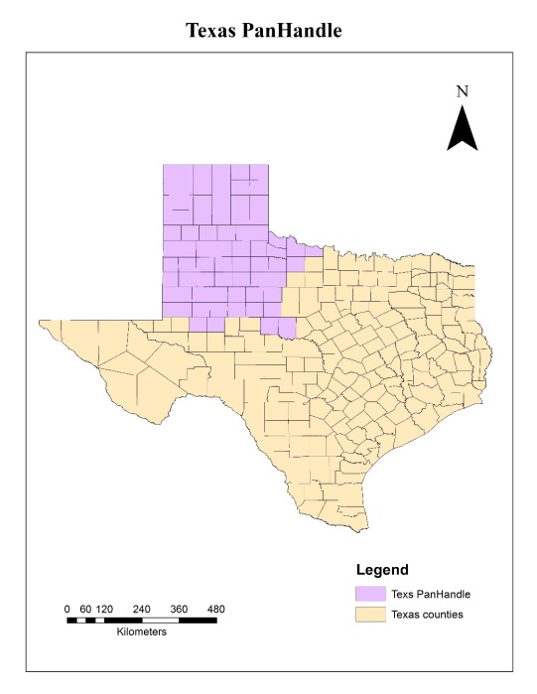

**Figure 1: Texas PanHandle region**

**Technologies and Languages:**

* Website design: Google map API, JavaScript, JQuery, HTML 5, CSS 3.0, Fancy box, High chart
* Database Server: Microsoft SQL Server 2012.
* Web Server: IIS
* Data sharing and backup: Github

**Architecture:**

The first step in the creation of TPCC involved designing a database that included county polygon geographic information, county general information (population, area), and the county base bias corrected climate datasets for the three models. 18 CSV files were created and inner joined with the counties file using SQL commands. The entire database was hosted on Microsoft SQL server 2012 (Figure 2). The county polygon geographic information was extracted from the Google fusion tables. The polygon geographic information was converted to the required Well-Known Text (WKT) format needed to be stored on the SQL server. WKT format was defined by the Open Geospatial Consortium (OGC) and additional information about OGC can be found at <http://www.opengeospatial.org/ogc>. A JSON page containing WKT, general information, and climate datasets for all the three models for each county was generated using JQuery. The data from the JSON page was used to generate the county polygons and HighChart graphs that overlay the Google map. The entire web service was hosted on Microsoft Internet Information System (IIS) (Figure 2). The page was designed using Hypertext mark-up language (HTML5), cascading style sheets (CSS3) and Google Map API JavaScript.

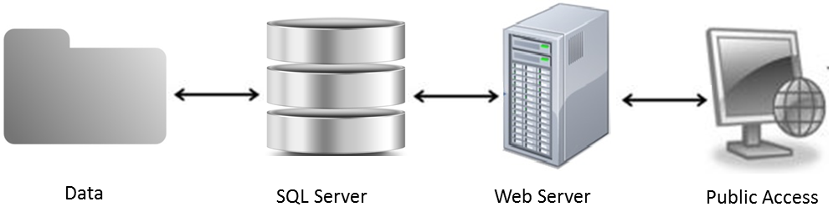

**Figure 2: Diagrammatic representation of the architecture involved in creating TPCC**

**Web Design:**

The main idea behind the web design is to keep it simple, easily navigable and make it work on different screen sizes for web. HTML 5 and CSS 5 has been used to design and built the web page. Lists and div elements were used (Figure 3). The webpage have all the basic elements with banner and footer.

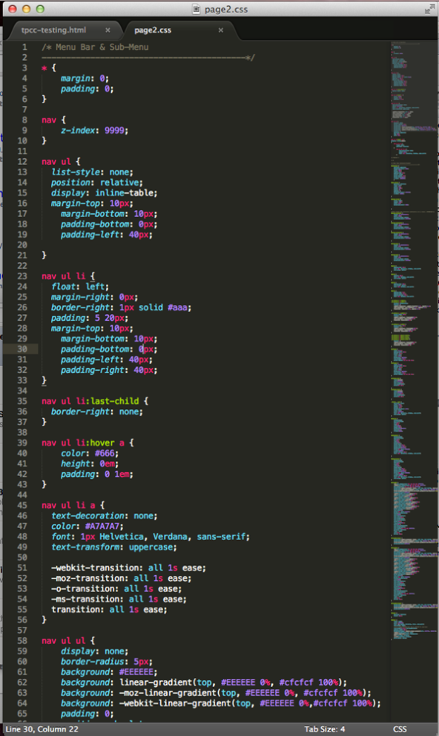

Figure 3: CSS code that we used for styling the webpage

**Results:**

After confirming the bias correction results were reasonable, the output datasets for each county after bias correction were used in developing the database required for the TPCC application. TPCC interactive online application provides the user with the ability to view the temporal and spatial variability of historic and future climate change across the region for the three climate models (Figure 5). Users can access the monthly mean rainfall, ensemble mean temperature, mean maximum temperature, and mean minimum temperature predicted by each climate model for each county. Users can also access the ensemble of the three climate model predictions. Figure 5 shows the home page an. the navigation bar on which users can select their climate models by clicking the “CLIMATE MODELS” menu item. “ABOUT DATA” provides the users with a brief description about the climate models, climate datasets and methodology employed in correcting the datasets and references. Users can request the monthly and daily bias corrected climate datasets for all the three models by e-mailing us, the details of which can be found under the “CONTACT US” menu item on the navigation bar.

A new feature called “Info Bubble” (Figure 4) has been added to the webpage. When a user clicks on any county polygon, the info bubble will pop up with two different tabs (Figure 4), the county tab and the ensemble historic tab. County tab provides general information about the county, like area and population, and the ensemble historic tab provides the ensemble average of historic mean temperature and rainfall.

In the graphs to the right of the webpage, the user is provided with the capability of viewing only historic or only future or both by clicking the legend at the base of each chart. When a user hovers the mouse cursor on a marker in the chart, the month and the quantitative value associated with that month will pop up. The default base map used in the application is a Google Terrain map, but the user can also select a satellite base map if they wish The use of Google Maps API and HighCharts enhances the user’s experience as they are provided with additional tools to interact with the website, like built-in zoom in and zoom out functionality, and the ability to pan across the region.

Website Link: <http://geog489-10.tamu.edu/Project/main.aspx>

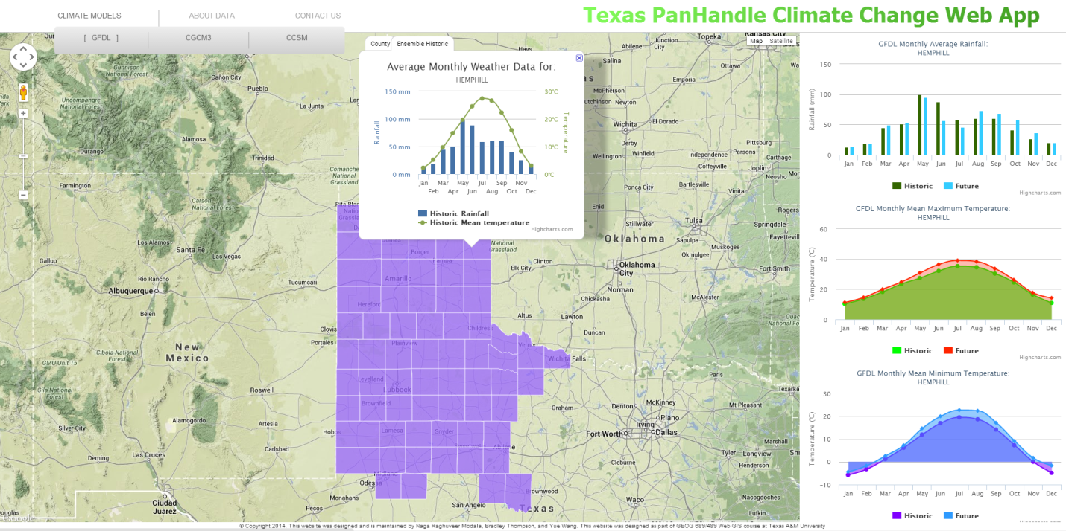

Figure 5: Homepage of TPCC displaying GFDL climate predictions for Hemphil County.

|  |  |
| --- | --- |
|  |  |
| Figure 4: Info bubble with two tabs | |

**Challenges/ Failures to implement**

* Failed to implement Multi polygon select
* Custom pop up boxes – Ad blocker in some browsers blocked the popups
* Info Bubble – third Tab – Slow refreshing rate of the third tab

**Contributions:**

* Raghuveer Modala, Yue Wang – Handling datasets, database design, SQL, High Charts, County Polygons, Info Bubble, styling.
* Bradley Thompson – Web design and styling, Debugging and Testing.